Texas Commission on Environmental Quality

Table 10

Cyclone Separators

Emission Point No. (from flow diagram):
Manufacturer: |  |  |  |  | Model No. (if available):
Name of Abatement Device: |  |  |  |  | Type of Particulate Controlled:
Gas Stream Characteristics
Flow Rate (acfm) |  |  |  | Gas Stream Temperature (°F) |  | Particulate Grain Loading (grain/scf)
Design Maximum: |  | Average Expected: |  |  |  | Inlet: |  | Outlet:
Particulate Distribution (by weight)
Micron Range |  |  | Inlet |  |  |  | Outlet
0.0-1.0 |  |  | % |  |  |  | %
1.0-3.0 |  |  | % |  |  |  | %
3.0-5.0 |  |  | % |  |  |  | %
5-10 |  |  | % |  |  |  | %
10-20 |  |  | % |  |  |  | %
over 20 |  |  | % |  |  |  | %
Cyclone Characteristics
Type of Cyclone (check all that apply):
Wet | Dry |  | Single |  | Dual |  | Quadruple |  | Multi-clone

Texas Commission on Environmental Quality

Table 10
Cyclone Separators

Cyclone Characteristics (continued)
Give Dimensions of Cyclone (inches)  See sample sketch | 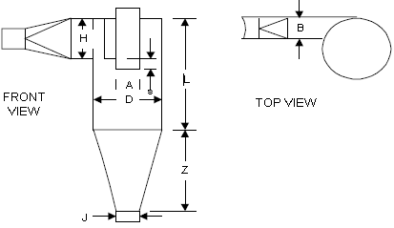
B:
H:
S:
L:
Z:
D:
A:
J:
Method of removal of particulate from cyclone:

Pressure drop through cyclone (inches water):

Additional Information
On separate sheets attach the following:
- Details regarding principle of operation.
- An assembly drawing (front and top view) of the abatement device dimensioned and to scale clearly showing the design, size, and shape. If the device has bypasses, safety valves, etc., include those items in the drawing and specify when such bypasses are to be used and under what conditions.

